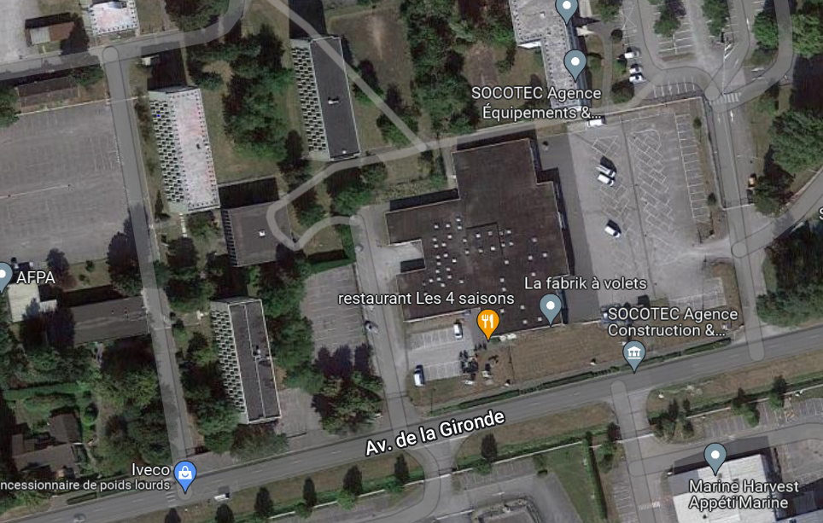

AFPA

AFPA

AFPA